UNITED STATES
SECURITIES AND EXCHANGE COMMISSION
Washington, DC 20549
______________________________________________________________

FORM 8-K

CURRENT REPORT

Pursuant to Section 13 or 15(d) of the
Securities Exchange Act of 1934

Date of report (Date of earliest event reported): May 5, 2026

KADANT INC.
(Exact name of registrant as specified in its charter)

Commission file number 001-11406
Delaware |  |  |  |  |  |  |  |  | 52-1762325
(State or other jurisdiction of incorporation or organization) |  |  |  |  |  |  |  |  | (I.R.S. Employer Identification No.)
One Technology Park Drive
Westford, Massachusetts 01886
(Address of principal executive offices, including zip code)
(978) 776-2000
(Registrant's telephone number, including area code)

Check the appropriate box below if the Form 8-K filing is intended to simultaneously satisfy the filing obligation of the registrant under any of the following provisions:
 |  |  | ☐ |  |  | Written communications pursuant to Rule 425 under the Securities Act (17 CFR 230.425)
 |  |  | ☐ |  |  | Soliciting material pursuant to Rule 14a-12 under the Exchange Act (17 CFR 240.14a-12)
 |  |  | ☐ |  |  | Pre-commencement communications pursuant to Rule 14d-2(b) under the Exchange Act (17 CFR 240.14d-2(b))
 |  |  | ☐ |  |  | Pre-commencement communications pursuant to Rule 13e-4(c) under the Exchange Act (17 CFR 240.13e-4(c))

Securities registered pursuant to Section 12(b) of the Securities Exchange Act of 1934:
Title of each class |  |  |  |  |  | Trading Symbol(s) |  |  |  |  |  | Name of each exchange on which registered
Common Stock, $.01 par value |  |  |  |  |  | KAI |  |  |  |  |  | New York Stock Exchange

Indicate by check mark whether the registrant is an emerging growth company as defined in Rule 405 of the Securities Act of 1933 (§230.405 of this chapter) or Rule 12b-2 of the Securities Exchange Act of 1934 (§240.12b-2 of this chapter). Emerging growth company ☐

If an emerging growth company, indicate by check mark if the registrant has elected not to use the extended transition period for complying with any new or revised financial accounting standards provided pursuant to Section 13(a) of the Exchange Act. ☐

KADANT INC.
Item 2.02. Results of Operations and Financial Condition.

On May 5, 2026, Kadant Inc. (the “Company”) announced its financial results for the fiscal quarter ended April 4, 2026. The full text of the press release issued in connection with the announcement is furnished as Exhibit 99.1 to this Current Report on Form 8-K.

Item 7.01. Regulation FD Disclosure.

On May 6, 2026, the Company will hold a webcast and conference call to discuss its financial results for the fiscal quarter ended April 4, 2026. A copy of the slides that will be presented on the webcast and discussed in the conference call is furnished as Exhibit 99.2 to this Current Report on Form 8-K.

The information in Item 2.02 and Item 7.01 of this Form 8-K (including Exhibits 99.1 and 99.2) shall not be deemed “filed” for purposes of Section 18 of the Securities Exchange Act of 1934, as amended (the “Exchange Act”), or otherwise subject to the liabilities of that section, nor shall it be deemed incorporated by reference in any filing under the Securities Act of 1933 or the Exchange Act, except as expressly set forth by specific reference in such a filing.

Item 9.01. Financial Statements and Exhibits.

(d) Exhibits
 |  |  | The following exhibits relating to Item 2.02 and Item 7.01 shall be deemed to be furnished and not filed.
 |  |  | Exhibit
 |  |  | No. |  |  | Description of Exhibits
 |  |  | 99.1 |  |  | Press Release issued by the Company on May 5, 2026 announcing its financial results.
 |  |  | 99.2 |  |  | Slides to be presented by the Company on May 6, 2026.
 |  |  | 104 |  |  | Cover Page Interactive Data File (embedded within the Inline XBRL document).

2

KADANT INC.
SIGNATURE

Pursuant to the requirements of the Securities Exchange Act of 1934, as amended, the registrant has duly caused this report to be signed on its behalf by the undersigned hereunto duly authorized.
 |  |  |  |  |  | KADANT INC.
Date: May 5, 2026 |  |  | By |  |  | /s/ Michael J. McKenney
Michael J. McKenney
Executive Vice President and Chief Financial Officer

3

Exhibit 99.1
PRESS RELEASE
KADANT INC.
One Technology Park Drive
Westford, MA 01886 USA
Tel: +1 978-776-2000
www.kadant.com

Kadant Reports First Quarter 2026 Results

WESTFORD, Mass., May 5, 2026 - Kadant Inc. (NYSE: KAI) reported its financial results for the first quarter ended April 4, 2026.

First Quarter Financial Highlights
•Bookings increased 25% to a record $321 million
•Revenue increased 18% to $282 million
•Gross margin decreased 110 basis points to 45.0%
•Net income increased 6% to $26 million
•GAAP EPS increased 6% to $2.16
•Adjusted EPS increased 14% to $2.84
•Adjusted EBITDA increased 19% to $57 million and represented 20.2% of revenue
•Operating cash flow decreased 4% to $22 million
•Backlog was $326 million

Note: Percent changes above are based on comparison to the prior year period. All references to earnings per share (EPS) are to our EPS as calculated on a diluted basis. Adjusted EPS, adjusted EBITDA, adjusted EBITDA margin, free cash flow, and changes in organic revenue are non-GAAP financial measures that exclude certain items as detailed later in this press release under the heading “Use of Non-GAAP Financial Measures.”

Management Commentary
“We had an excellent start to the year highlighted by robust demand and solid earnings growth,” said Jeffrey L. Powell, president and chief executive officer of Kadant. “Strong demand for our aftermarket parts combined with our recent acquisitions led to record bookings and aftermarket parts revenue along with healthy margin performance.”

First Quarter 2026 Compared to 2025
Revenue increased 18 percent to $281.5 million compared to $239.2 million in 2025. Organic revenue decreased one percent, which excludes an increase of 14 percent from acquisitions. Gross margin was 45.0 percent, which includes a 50 basis point decrease from acquisition-related costs, compared to 46.1 percent in 2025.

Net income was $25.5 million, increasing six percent compared to $24.1 million in 2025. GAAP EPS increased six percent to $2.16 compared to $2.04 in 2025 and adjusted EPS increased 14 percent to $2.84 compared to $2.50 in 2025. Adjusted EPS excludes intangible asset amortization expense of $0.53 and acquisition-related costs of $0.15 in 2026, and intangible asset amortization expense of $0.40 and acquisition-related costs of $0.06 in 2025.

Adjusted EBITDA increased 19 percent to $56.8 million and represented 20.2 percent of revenue in 2026 compared to $47.9 million and 20.0 percent of revenue in 2025. Operating cash flow decreased four percent to $21.9 million compared to $22.8 million in 2025. Free cash flow decreased two percent to $18.7 million compared to $19.0 million in 2025.

Kadant Reports First Quarter 2026 Results
May 5, 2026
Page 2
Bookings increased 25 percent to a record $320.8 million compared to $256.2 million in 2025. Organic bookings increased ten percent, which excludes increases of 11 percent from acquisitions and four percent from the favorable effect of foreign currency translation.

Summary and Outlook
“Our strong start to the year is encouraging, and we expect capital project activity to continue improving,” Mr. Powell continued. “That said, project timing is more uncertain due to heightened geopolitical challenges. We are revising our guidance to reflect our recent acquisition and expect revenue of $1.178 to $1.203 billion in 2026, up from our previous guidance of $1.160 to $1.185 billion. We now expect GAAP EPS of $9.80 to $10.15 in 2026, revised from our previous guidance of $10.27 to $10.62, and adjusted EPS of $12.33 to $12.68, revised from our prior guidance of $12.53 to $12.88. The $0.20 decrease in adjusted EPS relates to our recent acquisition, which will be dilutive in the short term as income is deferred until Kadant's previously acquired inventory is sold to third-party customers. The 2026 adjusted EPS guidance excludes $2.53 of acquisition-related costs, revised from $2.26 in our previous guidance. For the second quarter of 2026, we expect revenue of $296 to $306 million, GAAP EPS of $2.26 to $2.36 and, after excluding $0.62 of acquisition-related costs, adjusted EPS of $2.88 to $2.98.”

Conference Call
Kadant will hold a webcast with a slide presentation for investors on Wednesday, May 6, 2026, at 11:00 a.m. Eastern Time to discuss its first quarter financial performance, as well as future expectations. To listen to the call live and view the webcast, go to the “Investors” section of the Company’s website at kadant.com. Participants interested in joining the call’s live question and answer session are required to register by visiting https://register-conf.media-server.com/register/BI2e8652034d3040b28a319a3ea0e02012 or selecting the Q&A link on our website to receive a dial-in number and unique PIN. It is recommended that you join the call 10 minutes prior to the start of the event. A replay of the webcast presentation will be available on our website through June 5, 2026.

Prior to the call, our earnings release and the slides used in the webcast presentation will be filed with the Securities and Exchange Commission and will be available at sec.gov. After the webcast, Kadant will post its updated general investor presentation incorporating the first quarter results on its website at kadant.com under the “Investors” section.

Use of Non-GAAP Financial Measures
In addition to the financial measures prepared in accordance with generally accepted accounting principles (GAAP), we use certain non-GAAP financial measures, including increases or decreases in revenue excluding the effect of acquisitions and foreign currency translation (organic revenue), adjusted operating income, adjusted net income, adjusted EPS, earnings before interest, taxes, depreciation, and amortization (EBITDA), adjusted EBITDA, adjusted EBITDA margin, and free cash flow.

We use organic revenue to understand our trends and to forecast and evaluate our financial performance and compare revenue to prior periods. Organic revenue excludes revenue from acquisitions for the four quarterly reporting periods following the date of the acquisition and the effect of foreign currency translation. Revenue in the first quarter of 2026 included $34.0 million from acquisitions and a favorable foreign currency translation effect of $9.8 million compared to the first quarter of 2025. Our other non-GAAP financial measures exclude amortization expense related to acquired intangible assets, profit in inventory, and backlog (collectively, purchase accounting expenses); acquisition costs; and other income or expense, as indicated. We exclude purchase accounting expenses and acquisition costs to provide a more meaningful and consistent comparison of our operating results over time and with peer companies. While we have a history of acquisition activity, such transactions do not occur on a predictable cycle, and the size and nature of these transactions will vary. We believe it is important for investors to understand that these intangible assets were recorded as part of purchase accounting and that they contribute to revenue generation. We also exclude other items as they are not indicative of our core operating results and are not comparable to other periods, which have differing levels of incremental costs, expenditures or income, or none at all. Additionally, we use free cash flow in order to provide insight on our ability to generate cash for acquisitions and debt repayments, as well as for other investing and financing activities.

Kadant Reports First Quarter 2026 Results
May 5, 2026
Page 3
We believe these non-GAAP financial measures, when taken together with the corresponding GAAP financial measures, provide meaningful supplemental information regarding our performance by excluding certain items that may not be indicative of our core business, operating results, or future outlook. We believe that the inclusion of such measures helps investors gain an understanding of our underlying operating performance and future prospects, consistent with how management measures and forecasts our performance, especially when comparing such results to previous periods or forecasts and to the performance of our competitors. Such measures are also used by us in our financial and operating decision-making and for compensation purposes. We also believe this information is responsive to investors' requests and gives them additional measures of our performance.

The non-GAAP financial measures included in this press release are not meant to be considered superior to or a substitute for the results of operations or cash flows prepared in accordance with GAAP. In addition, the non-GAAP financial measures included in this press release have limitations associated with their use as compared to the most directly comparable GAAP measures, in that they may be different from, and therefore not comparable to, similar measures used by other companies.

First Quarter
Adjusted operating income, adjusted EBITDA, and adjusted EBITDA margin exclude:
•Pre-tax intangible asset amortization expense of $8.4 million in 2026 and $6.3 million in 2025.
•Pre-tax profit in inventory and backlog amortization expense of $1.4 million in 2026 and $0.4 million in 2025.
•Pre-tax acquisition costs of $0.7 million in 2026 and $0.3 million in 2025.

Adjusted net income and adjusted EPS exclude:
•After-tax intangible asset amortization expense of $6.3 million ($8.4 million plus tax of $2.1 million) in 2026 and $4.8 million ($6.3 million net of tax of $1.5 million) in 2025.
•After-tax profit in inventory and backlog amortization expense of $1.1 million ($1.4 million net of tax of $0.3 million) in 2026 and $0.3 million ($0.4 million net of tax of $0.1 million) in 2025.
•After-tax acquisition costs of $0.7 million in 2026 and $0.3 million in 2025.

Free cash flow is calculated as operating cash flow less:
•Capital expenditures of $3.3 million in 2026 and $3.8 million in 2025.

Reconciliations of the non-GAAP financial measures to the most directly comparable GAAP financial measures are set forth in this press release.

-more-
Kadant Reports First Quarter 2026 Results
May 5, 2026
Page 4
Financial Highlights (unaudited)
(In thousands, except per share amounts and percentages)
 |  |  |  |  |  |  |  |  |  |  |  | Three Months Ended
Consolidated Statement of Income |  |  |  |  |  |  |  |  |  |  |  | April 4,  2026 |  |  |  |  |  | March 29,  2025
Revenue |  |  |  |  |  |  |  |  |  |  |  | $ | 281,505 |  |  |  |  | $ | 239,210
Costs and Operating Expenses:
 |  |  | Cost of revenue |  |  |  |  |  |  |  |  | 154,802 |  |  |  |  |  | 128,880
 |  |  | Selling, general, and administrative expenses |  |  |  |  |  |  |  |  | 82,538 |  |  |  |  |  | 71,221
 |  |  | Research and development expenses |  |  |  |  |  |  |  |  | 4,056 |  |  |  |  |  | 3,523
 |  |  |  |  |  |  |  |  |  |  |  | 241,396 |  |  |  |  |  | 203,624
Operating Income |  |  |  |  |  |  |  |  |  |  |  | 40,109 |  |  |  |  |  | 35,586
Interest Income |  |  |  |  |  |  |  |  |  |  |  | 351 |  |  |  |  |  | 517
Interest Expense |  |  |  |  |  |  |  |  |  |  |  | (4,484) |  |  |  |  |  | (3,822)
Other Expense, Net |  |  |  |  |  |  |  |  |  |  |  | (13) |  |  |  |  |  | (16)
Income Before Provision for Income Taxes |  |  |  |  |  |  |  |  |  |  |  | 35,963 |  |  |  |  |  | 32,265
Provision for Income Taxes |  |  |  |  |  |  |  |  |  |  |  | 10,142 |  |  |  |  |  | 7,828
Net Income |  |  |  |  |  |  |  |  |  |  |  | 25,821 |  |  |  |  |  | 24,437
Net Income Attributable to Noncontrolling Interests |  |  |  |  |  |  |  |  |  |  |  | (312) |  |  |  |  |  | (374)
Net Income Attributable to Kadant |  |  |  |  |  |  |  |  |  |  |  | $ | 25,509 |  |  |  |  | $ | 24,063
Earnings per Share Attributable to Kadant:
 |  |  |  |  |  | Basic |  |  |  |  |  | $ | 2.16 |  |  |  |  | $ | 2.05
 |  |  |  |  |  | Diluted |  |  |  |  |  | $ | 2.16 |  |  |  |  | $ | 2.04
Weighted Average Shares:
 |  |  |  |  |  | Basic |  |  |  |  |  | 11,794 |  |  |  |  |  | 11,760
 |  |  |  |  |  | Diluted |  |  |  |  |  | 11,802 |  |  |  |  |  | 11,776

 |  |  |  |  |  |  |  |  |  |  |  | Three Months Ended |  |  |  |  |  |  |  |  |  |  |  | Three Months Ended
Adjusted Net Income and Adjusted Diluted EPS (a) |  |  |  |  |  |  |  |  |  |  |  | April 4,  2026 |  |  |  |  |  | April 4,  2026 |  |  |  |  |  | March 29,  2025 |  |  |  |  |  | March 29,  2025
Net Income and Diluted EPS Attributable to Kadant, as Reported |  |  |  |  |  |  |  |  |  |  |  | $ | 25,509 |  |  |  |  | $ | 2.16 |  |  |  |  | $ | 24,063 |  |  |  |  | $ | 2.04
Adjustments, Net of Tax:
 |  |  | Intangible Asset Amortization |  |  |  |  |  |  |  |  | 6,308 |  |  |  |  |  | 0.53 |  |  |  |  |  | 4,753 |  |  |  |  |  | 0.40
 |  |  | Profit in Inventory and Backlog Amortization |  |  |  |  |  |  |  |  | 1,057 |  |  |  |  |  | 0.09 |  |  |  |  |  | 296 |  |  |  |  |  | 0.03
 |  |  | Acquisition Costs |  |  |  |  |  |  |  |  | 671 |  |  |  |  |  | 0.06 |  |  |  |  |  | 315 |  |  |  |  |  | 0.03
Adjusted Net Income and Adjusted Diluted EPS (a,b) |  |  |  |  |  |  |  |  |  |  |  | $ | 33,545 |  |  |  |  | $ | 2.84 |  |  |  |  | $ | 29,427 |  |  |  |  | $ | 2.50

 |  |  |  |  |  |  |  |  |  |  |  | Three Months Ended |  |  |  |  |  |  |  |  |  |  |  |  |  |  |  |  |  | Increase (Decrease)  Excluding Acquisitions and FX (a,c)
Revenue by Segment |  |  |  |  |  |  |  |  |  |  |  | April 4,  2026 |  |  |  |  |  | March 29,  2025 |  |  |  |  |  | Increase
Flow Control |  |  |  |  |  |  |  |  |  |  |  | $ | 98,608 |  |  |  |  | $ | 92,441 |  |  |  |  | $ | 6,167 |  |  |  |  | $ | 1,372
Industrial Processing |  |  |  |  |  |  |  |  |  |  |  | 123,038 |  |  |  |  |  | 89,524 |  |  |  |  |  | 33,514 |  |  |  |  |  | (3,957)
Material Handling |  |  |  |  |  |  |  |  |  |  |  | 59,859 |  |  |  |  |  | 57,245 |  |  |  |  |  | 2,614 |  |  |  |  |  | 1,058
 |  |  |  |  |  |  |  |  |  |  |  | $ | 281,505 |  |  |  |  | $ | 239,210 |  |  |  |  | $ | 42,295 |  |  |  |  | $ | (1,527)
Percentage of Parts and Consumables Revenue |  |  |  |  |  |  |  |  |  |  |  | 74% |  |  |  |  |  | 75%
-more-
Kadant Reports First Quarter 2026 Results
May 5, 2026
Page 5
 |  |  |  |  |  |  |  |  |  |  |  | Three Months Ended |  |  |  |  |  |  |  |  |  |  |  | Increase |  |  |  |  |  | Increase (Decrease)  Excluding Acquisitions and FX (c)
Bookings by Segment |  |  |  |  |  |  |  |  |  |  |  | April 4,  2026 |  |  |  |  |  | March 29,  2025
Flow Control |  |  |  |  |  |  |  |  |  |  |  | $ | 111,546 |  |  |  |  | $ | 99,987 |  |  |  |  | $ | 11,559 |  |  |  |  | $ | 6,392
Industrial Processing |  |  |  |  |  |  |  |  |  |  |  | 144,502 |  |  |  |  |  | 92,366 |  |  |  |  |  | 52,136 |  |  |  |  |  | 21,022
Material Handling |  |  |  |  |  |  |  |  |  |  |  | 64,747 |  |  |  |  |  | 63,865 |  |  |  |  |  | 882 |  |  |  |  |  | (1,057)
 |  |  |  |  |  |  |  |  |  |  |  | $ | 320,795 |  |  |  |  | $ | 256,218 |  |  |  |  | $ | 64,577 |  |  |  |  | $ | 26,357
Percentage of Parts and Consumables Bookings |  |  |  |  |  |  |  |  |  |  |  | 71% |  |  |  |  |  | 74%
 |  |  |  |  |  |  |  |  |  |  |  | Three Months Ended
Additional Segment Information |  |  |  |  |  |  |  |  |  |  |  | April 4,  2026 |  |  |  |  |  | March 29,  2025
Gross Margin:
 |  |  |  |  |  | Flow Control |  |  |  |  |  | 52.7% |  |  |  |  |  | 53.3%
 |  |  |  |  |  | Industrial Processing |  |  |  |  |  | 42.5% |  |  |  |  |  | 44.1%
 |  |  |  |  |  | Material Handling |  |  |  |  |  | 37.5% |  |  |  |  |  | 37.7%
 |  |  |  |  |  | Consolidated |  |  |  |  |  | 45.0% |  |  |  |  |  | 46.1%
Operating Income:
 |  |  |  |  |  | Flow Control |  |  |  |  |  | $ | 24,204 |  |  |  |  | $ | 22,752
 |  |  |  |  |  | Industrial Processing |  |  |  |  |  | 19,913 |  |  |  |  |  | 16,832
 |  |  |  |  |  | Material Handling |  |  |  |  |  | 7,466 |  |  |  |  |  | 7,535
 |  |  |  |  |  | Corporate |  |  |  |  |  | (11,474) |  |  |  |  |  | (11,533)
 |  |  |  |  |  |  |  |  |  |  |  | $ | 40,109 |  |  |  |  | $ | 35,586
Adjusted Operating Income (a,b,d):
 |  |  |  |  |  | Flow Control |  |  |  |  |  | $ | 25,474 |  |  |  |  | $ | 24,366
 |  |  |  |  |  | Industrial Processing |  |  |  |  |  | 26,423 |  |  |  |  |  | 19,344
 |  |  |  |  |  | Material Handling |  |  |  |  |  | 10,154 |  |  |  |  |  | 10,427
 |  |  |  |  |  | Corporate |  |  |  |  |  | (11,474) |  |  |  |  |  | (11,533)
 |  |  |  |  |  |  |  |  |  |  |  | $ | 50,577 |  |  |  |  | $ | 42,604
Capital Expenditures:
 |  |  |  |  |  | Flow Control |  |  |  |  |  | $ | 1,022 |  |  |  |  | $ | 1,509
 |  |  |  |  |  | Industrial Processing |  |  |  |  |  | 863 |  |  |  |  |  | 1,325
 |  |  |  |  |  | Material Handling |  |  |  |  |  | 1,236 |  |  |  |  |  | 999
 |  |  |  |  |  | Corporate |  |  |  |  |  | 137 |  |  |  |  |  | 3
 |  |  |  |  |  |  |  |  |  |  |  | $ | 3,258 |  |  |  |  | $ | 3,836
 |  |  |  |  |  |  |  |  |  |  |  | Three Months Ended
Cash Flow and Other Data |  |  |  |  |  |  |  |  |  |  |  | April 4,  2026 |  |  |  |  |  | March 29,  2025
Operating Cash Flow |  |  |  |  |  |  |  |  |  |  |  | $ | 21,916 |  |  |  |  | $ | 22,835
Capital Expenditures |  |  |  |  |  |  |  |  |  |  |  | (3,258) |  |  |  |  |  | (3,836)
Free Cash Flow (a) |  |  |  |  |  |  |  |  |  |  |  | $ | 18,658 |  |  |  |  | $ | 18,999
Depreciation and Amortization Expense |  |  |  |  |  |  |  |  |  |  |  | $ | 14,647 |  |  |  |  | $ | 12,013

-more-
Kadant Reports First Quarter 2026 Results
May 5, 2026
Page 6
Balance Sheet Data |  |  |  |  |  |  |  |  |  |  |  |  |  |  |  |  |  |  |  |  |  |  |  | April 4,  2026 |  |  |  |  |  | January 3,  2026
Assets
Cash, Cash Equivalents, and Restricted Cash |  |  |  |  |  |  |  |  |  |  |  |  |  |  |  |  |  |  |  |  |  |  |  | $ | 119,817 |  |  |  |  | $ | 122,681
Accounts Receivable, Net |  |  |  |  |  |  |  |  |  |  |  |  |  |  |  |  |  |  |  |  |  |  |  | 172,376 |  |  |  |  |  | 158,567
Inventories |  |  |  |  |  |  |  |  |  |  |  |  |  |  |  |  |  |  |  |  |  |  |  | 214,831 |  |  |  |  |  | 206,854
Contract Assets |  |  |  |  |  |  |  |  |  |  |  |  |  |  |  |  |  |  |  |  |  |  |  | 5,921 |  |  |  |  |  | 6,599
Property, Plant, and Equipment, Net |  |  |  |  |  |  |  |  |  |  |  |  |  |  |  |  |  |  |  |  |  |  |  | 193,286 |  |  |  |  |  | 196,656
Intangible Assets |  |  |  |  |  |  |  |  |  |  |  |  |  |  |  |  |  |  |  |  |  |  |  | 341,170 |  |  |  |  |  | 350,376
Goodwill |  |  |  |  |  |  |  |  |  |  |  |  |  |  |  |  |  |  |  |  |  |  |  | 551,088 |  |  |  |  |  | 555,621
Other Assets |  |  |  |  |  |  |  |  |  |  |  |  |  |  |  |  |  |  |  |  |  |  |  | 116,163 |  |  |  |  |  | 114,824
 |  |  |  |  |  |  |  |  |  |  |  |  |  |  |  |  |  |  |  |  |  |  |  | $ | 1,714,652 |  |  |  |  | $ | 1,712,178
Liabilities and Stockholders' Equity
Accounts Payable |  |  |  |  |  |  |  |  |  |  |  |  |  |  |  |  |  |  |  |  |  |  |  | $ | 55,481 |  |  |  |  | $ | 53,362
Debt Obligations |  |  |  |  |  |  |  |  |  |  |  |  |  |  |  |  |  |  |  |  |  |  |  | 361,256 |  |  |  |  |  | 372,720
Other Borrowings |  |  |  |  |  |  |  |  |  |  |  |  |  |  |  |  |  |  |  |  |  |  |  | 2,105 |  |  |  |  |  | 1,781
Other Liabilities |  |  |  |  |  |  |  |  |  |  |  |  |  |  |  |  |  |  |  |  |  |  |  | 289,661 |  |  |  |  |  | 293,248
 |  |  | Total Liabilities |  |  |  |  |  |  |  |  |  |  |  |  |  |  |  |  |  |  |  |  | 708,503 |  |  |  |  |  | 721,111
 |  |  | Stockholders' Equity |  |  |  |  |  |  |  |  |  |  |  |  |  |  |  |  |  |  |  |  | 1,006,149 |  |  |  |  |  | 991,067
 |  |  |  |  |  |  |  |  |  |  |  |  |  |  |  |  |  |  |  |  |  |  |  | $ | 1,714,652 |  |  |  |  | $ | 1,712,178
 |  |  |  |  |  |  |  |  |  |  |  | Three Months Ended
Adjusted Operating Income and Adjusted EBITDA Reconciliation (a) |  |  |  |  |  |  |  |  |  |  |  | April 4,  2026 |  |  |  |  |  | March 29,  2025
Consolidated
 |  |  |  |  |  | Net Income Attributable to Kadant |  |  |  |  |  | $ | 25,509 |  |  |  |  | $ | 24,063
 |  |  |  |  |  | Net Income Attributable to Noncontrolling Interests |  |  |  |  |  | 312 |  |  |  |  |  | 374
 |  |  |  |  |  | Provision for Income Taxes |  |  |  |  |  | 10,142 |  |  |  |  |  | 7,828
 |  |  |  |  |  | Interest Expense, Net |  |  |  |  |  | 4,133 |  |  |  |  |  | 3,305
 |  |  |  |  |  | Other Expense, Net |  |  |  |  |  | 13 |  |  |  |  |  | 16
 |  |  |  |  |  | Operating Income |  |  |  |  |  | 40,109 |  |  |  |  |  | 35,586
 |  |  |  |  |  | Intangible Asset Amortization Expense |  |  |  |  |  | 8,385 |  |  |  |  |  | 6,320
 |  |  |  |  |  | Profit in Inventory Amortization Expense (e) |  |  |  |  |  | 1,409 |  |  |  |  |  | 11
 |  |  |  |  |  | Backlog Amortization Expense (f) |  |  |  |  |  | — |  |  |  |  |  | 379
 |  |  |  |  |  | Acquisition Costs |  |  |  |  |  | 674 |  |  |  |  |  | 337
 |  |  |  |  |  | Indemnification Asset Provision (g) |  |  |  |  |  | — |  |  |  |  |  | (29)
 |  |  |  |  |  | Adjusted Operating Income (a,b) |  |  |  |  |  | 50,577 |  |  |  |  |  | 42,604
 |  |  |  |  |  | Depreciation Expense |  |  |  |  |  | 6,262 |  |  |  |  |  | 5,314
 |  |  |  |  |  | Adjusted EBITDA (a) |  |  |  |  |  | $ | 56,839 |  |  |  |  | $ | 47,918
 |  |  |  |  |  | Adjusted EBITDA Margin (a,h) |  |  |  |  |  | 20.2% |  |  |  |  |  | 20.0%
Flow Control
 |  |  |  |  |  | Operating Income |  |  |  |  |  | $ | 24,204 |  |  |  |  | $ | 22,752
 |  |  |  |  |  | Intangible Asset Amortization Expense |  |  |  |  |  | 1,270 |  |  |  |  |  | 1,214
 |  |  |  |  |  | Profit in Inventory Amortization Expense (e) |  |  |  |  |  | — |  |  |  |  |  | 11
 |  |  |  |  |  | Backlog Amortization Expense (f) |  |  |  |  |  | — |  |  |  |  |  | 279
 |  |  |  |  |  | Acquisition Costs |  |  |  |  |  | — |  |  |  |  |  | 8
 |  |  |  |  |  | Indemnification Asset Reversal (g) |  |  |  |  |  | — |  |  |  |  |  | 102
 |  |  |  |  |  | Adjusted Operating Income (a,b) |  |  |  |  |  | 25,474 |  |  |  |  |  | 24,366
 |  |  |  |  |  | Depreciation Expense |  |  |  |  |  | 1,927 |  |  |  |  |  | 1,798
 |  |  |  |  |  | Adjusted EBITDA (a) |  |  |  |  |  | $ | 27,401 |  |  |  |  | $ | 26,164
 |  |  |  |  |  | Adjusted EBITDA Margin (a,h) |  |  |  |  |  | 27.8% |  |  |  |  |  | 28.3%
-more-
Kadant Reports First Quarter 2026 Results
May 5, 2026
Page 7
 |  |  |  |  |  |  |  |  |  |  |  | Three Months Ended
Adjusted Operating Income and Adjusted EBITDA Reconciliation (a) |  |  |  |  |  |  |  |  |  |  |  | April 4,  2026 |  |  |  |  |  | March 29,  2025
Industrial Processing
 |  |  |  |  |  | Operating Income |  |  |  |  |  | $ | 19,913 |  |  |  |  | $ | 16,832
 |  |  |  |  |  | Intangible Asset Amortization Expense |  |  |  |  |  | 4,427 |  |  |  |  |  | 2,378
 |  |  |  |  |  | Profit in Inventory Amortization Expense (e) |  |  |  |  |  | 1,409 |  |  |  |  |  | —
 |  |  |  |  |  | Acquisition Costs |  |  |  |  |  | 674 |  |  |  |  |  | 340
 |  |  |  |  |  | Indemnification Asset Provision (g) |  |  |  |  |  | — |  |  |  |  |  | (206)
 |  |  |  |  |  | Adjusted Operating Income (a,b) |  |  |  |  |  | 26,423 |  |  |  |  |  | 19,344
 |  |  |  |  |  | Depreciation Expense |  |  |  |  |  | 3,110 |  |  |  |  |  | 2,347
 |  |  |  |  |  | Adjusted EBITDA (a) |  |  |  |  |  | $ | 29,533 |  |  |  |  | $ | 21,691
 |  |  |  |  |  | Adjusted EBITDA Margin (a,h) |  |  |  |  |  | 24.0% |  |  |  |  |  | 24.2%
Material Handling
 |  |  |  |  |  | Operating Income |  |  |  |  |  | $ | 7,466 |  |  |  |  | $ | 7,535
 |  |  |  |  |  | Intangible Asset Amortization Expense |  |  |  |  |  | 2,688 |  |  |  |  |  | 2,728
 |  |  |  |  |  | Backlog Amortization Expense (f) |  |  |  |  |  | — |  |  |  |  |  | 100
 |  |  |  |  |  | Acquisition Costs |  |  |  |  |  | — |  |  |  |  |  | (11)
 |  |  |  |  |  | Indemnification Asset Reversal (g) |  |  |  |  |  | — |  |  |  |  |  | 75
 |  |  |  |  |  | Adjusted Operating Income (a,b) |  |  |  |  |  | 10,154 |  |  |  |  |  | 10,427
 |  |  |  |  |  | Depreciation Expense |  |  |  |  |  | 1,212 |  |  |  |  |  | 1,158
 |  |  |  |  |  | Adjusted EBITDA (a) |  |  |  |  |  | $ | 11,366 |  |  |  |  | $ | 11,585
 |  |  |  |  |  | Adjusted EBITDA Margin (a,h) |  |  |  |  |  | 19.0% |  |  |  |  |  | 20.2%
Corporate
 |  |  |  |  |  | Operating Loss |  |  |  |  |  | $ | (11,474) |  |  |  |  | $ | (11,533)
 |  |  |  |  |  | Depreciation Expense |  |  |  |  |  | 13 |  |  |  |  |  | 11
 |  |  |  |  |  | EBITDA (a) |  |  |  |  |  | $ | (11,461) |  |  |  |  | $ | (11,522)
(a) |  |  |  |  |  | Represents a non-GAAP financial measure.
(b) |  |  |  |  |  | Reflects new methodology, announced on February 19, 2026, to exclude intangible asset amortization expense.
(c) |  |  |  |  |  | Represents the increase (decrease) resulting from the exclusion of acquisitions and from the conversion of current period amounts reported in local currencies into U.S. dollars at the exchange rate of the prior period compared to the U.S. dollar amount reported in the prior period.
(d) |  |  |  |  |  | See reconciliation to the most directly comparable GAAP financial measure under “Adjusted Operating Income and Adjusted EBITDA Reconciliation.”
(e) |  |  |  |  |  | Represents amortization expense within cost of revenue associated with acquired profit in inventory.
(f) |  |  |  |  |  | Represents intangible amortization expense associated with acquired backlog.
(g) |  |  |  |  |  | Represents the reversal of or provision for indemnification assets related to the release of or establishment of tax reserves associated with uncertain tax positions.
(h) |  |  |  |  |  | Calculated as adjusted EBITDA divided by revenue in each period.

About Kadant
Kadant Inc. is a global supplier of technologies and engineered systems that drive Sustainable Industrial Processing®. The Company’s products and services play an integral role in enhancing efficiency, optimizing energy utilization, and maximizing productivity in process industries. Kadant is based in Westford, Massachusetts, with approximately 4,000 employees in 22 countries worldwide. For more information, visit kadant.com.

-more-
Kadant Reports First Quarter 2026 Results
May 5, 2026
Page 8
Safe Harbor Statement
The following constitutes a “Safe Harbor” statement under the Private Securities Litigation Reform Act of 1995: This press release contains forward-looking statements that involve a number of risks and uncertainties, including forward-looking statements about our future financial and operating performance, demand for our products, and economic and industry outlook. These forward-looking statements represent our expectations as of the date of this press release. We undertake no obligation to publicly update any forward-looking statement, whether as a result of new information, future events, or otherwise. These forward-looking statements are subject to known and unknown risks and uncertainties that may cause our actual results to differ materially from these forward-looking statements as a result of various important factors, including those set forth under the heading “Risk Factors” in Kadant’s Annual Report on Form 10-K for the fiscal year ended January 3, 2026 and subsequent filings with the Securities and Exchange Commission. These include risks and uncertainties relating to adverse changes in global and local economic conditions; the variability and difficulty in accurately predicting revenues from large capital equipment and systems projects; our acquisition strategy; levels of residential construction activity; reductions by our wood processing customers of their capital spending or production of oriented strand board; changes to the global timber supply; development and use of digital media; cyclical economic conditions affecting the global mining industry; demand for coal, including economic and environmental risks associated with coal; failure of our information systems or breaches of data security and cybersecurity incidents; implementation of our internal growth strategy; competition; our ability to successfully manage our manufacturing operations; supply chain constraints, inflationary pressure, price increases or shortages in raw materials; loss of key personnel and effective succession planning; future restructurings; protection of intellectual property; changes to tax laws and regulations; climate change; adequacy of our insurance coverage; global operations; policies of the Chinese government; the variability and uncertainties in sales of capital equipment in China; currency fluctuations; changes to government regulations and policies around the world; compliance with government regulations and policies and compliance with laws; environmental laws and regulations; environmental, health and safety laws and regulations impacting the mining industry; our debt obligations; restrictions in our credit agreement and note purchase agreement; soundness of financial institutions; fluctuations in our share price; and anti-takeover provisions.

Contacts
Investor Contact Information:
Michael McKenney, 978-776-2000
IR@kadant.com

Media Contact Information:
Wes Martz, 978-776-2000
media@kadant.com

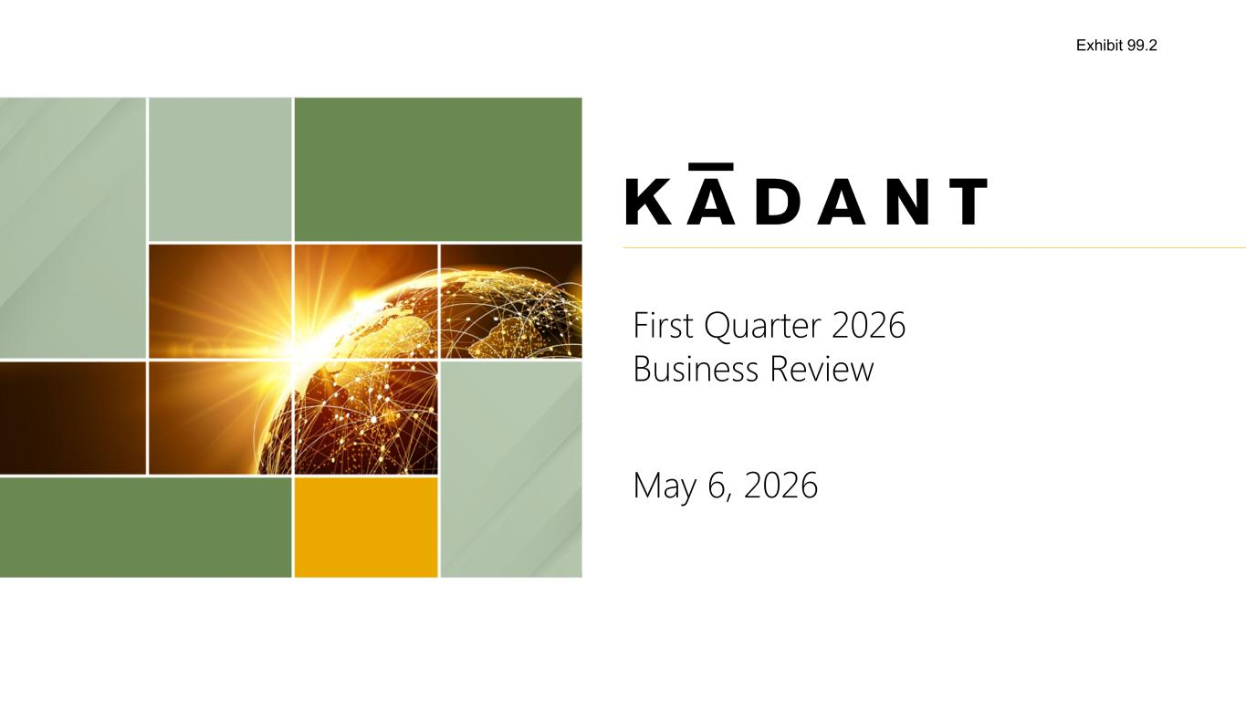

First Quarter 2026 Business Review May 6, 2026 Exhibit 99.2

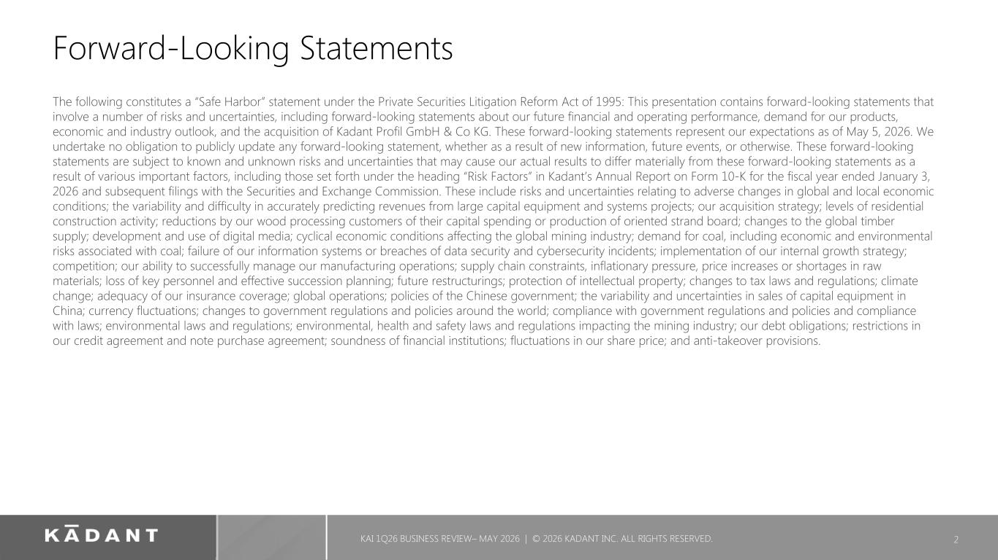
Forward-Looking Statements The following constitutes a “Safe Harbor” statement under the Private Securities Litigation Reform Act of 1995: This presentation contains forward-looking statements that involve a number of risks and uncertainties, including forward-looking statements about our future financial and operating performance, demand for our products, economic and industry outlook, and the acquisition of Kadant Profil GmbH & Co KG. These forward-looking statements represent our expectations as of May 5, 2026. We undertake no obligation to publicly update any forward-looking statement, whether as a result of new information, future events, or otherwise. These forward-looking statements are subject to known and unknown risks and uncertainties that may cause our actual results to differ materially from these forward-looking statements as a result of various important factors, including those set forth under the heading “Risk Factors” in Kadant’s Annual Report on Form 10-K for the fiscal year ended January 3, 2026 and subsequent filings with the Securities and Exchange Commission. These include risks and uncertainties relating to adverse changes in global and local economic conditions; the variability and difficulty in accurately predicting revenues from large capital equipment and systems projects; our acquisition strategy; levels of residential construction activity; reductions by our wood processing customers of their capital spending or production of oriented strand board; changes to the global timber supply; development and use of digital media; cyclical economic conditions affecting the global mining industry; demand for coal, including economic and environmental risks associated with coal; failure of our information systems or breaches of data security and cybersecurity incidents; implementation of our internal growth strategy; competition; our ability to successfully manage our manufacturing operations; supply chain constraints, inflationary pressure, price increases or shortages in raw materials; loss of key personnel and effective succession planning; future restructurings; protection of intellectual property; changes to tax laws and regulations; climate change; adequacy of our insurance coverage; global operations; policies of the Chinese government; the variability and uncertainties in sales of capital equipment in China; currency fluctuations; changes to government regulations and policies around the world; compliance with government regulations and policies and compliance with laws; environmental laws and regulations; environmental, health and safety laws and regulations impacting the mining industry; our debt obligations; restrictions in our credit agreement and note purchase agreement; soundness of financial institutions; fluctuations in our share price; and anti-takeover provisions. 2KAI 1Q26 BUSINESS REVIEW– MAY 2026 | © 2026 KADANT INC. ALL RIGHTS RESERVED.

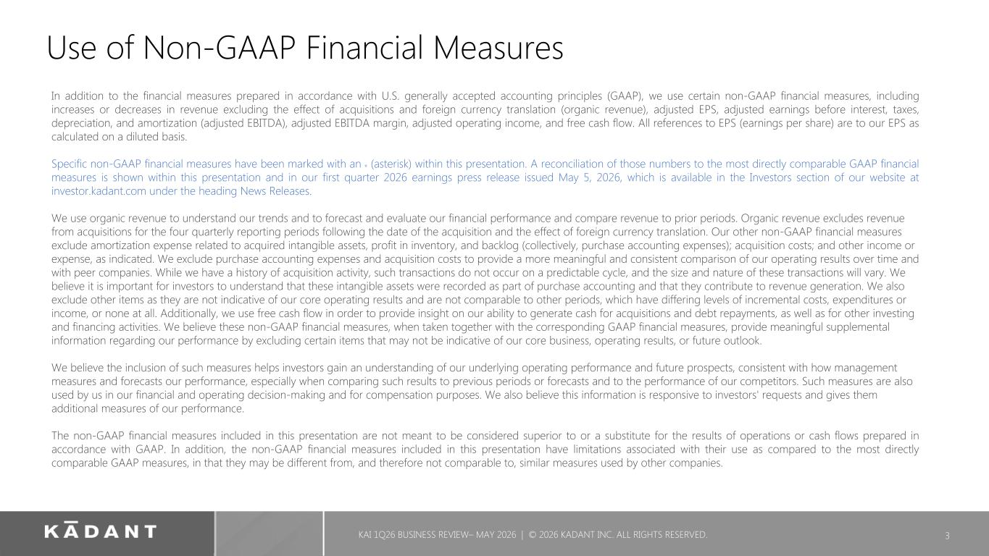
Use of Non-GAAP Financial Measures In addition to the financial measures prepared in accordance with U.S. generally accepted accounting principles (GAAP), we use certain non-GAAP financial measures, including increases or decreases in revenue excluding the effect of acquisitions and foreign currency translation (organic revenue), adjusted EPS, adjusted earnings before interest, taxes, depreciation, and amortization (adjusted EBITDA), adjusted EBITDA margin, adjusted operating income, and free cash flow. All references to EPS (earnings per share) are to our EPS as calculated on a diluted basis. Specific non-GAAP financial measures have been marked with an * (asterisk) within this presentation. A reconciliation of those numbers to the most directly comparable GAAP financial measures is shown within this presentation and in our first quarter 2026 earnings press release issued May 5, 2026, which is available in the Investors section of our website at investor.kadant.com under the heading News Releases. We use organic revenue to understand our trends and to forecast and evaluate our financial performance and compare revenue to prior periods. Organic revenue excludes revenue from acquisitions for the four quarterly reporting periods following the date of the acquisition and the effect of foreign currency translation. Our other non-GAAP financial measures exclude amortization expense related to acquired intangible assets, profit in inventory, and backlog (collectively, purchase accounting expenses); acquisition costs; and other income or expense, as indicated. We exclude purchase accounting expenses and acquisition costs to provide a more meaningful and consistent comparison of our operating results over time and with peer companies. While we have a history of acquisition activity, such transactions do not occur on a predictable cycle, and the size and nature of these transactions will vary. We believe it is important for investors to understand that these intangible assets were recorded as part of purchase accounting and that they contribute to revenue generation. We also exclude other items as they are not indicative of our core operating results and are not comparable to other periods, which have differing levels of incremental costs, expenditures or income, or none at all. Additionally, we use free cash flow in order to provide insight on our ability to generate cash for acquisitions and debt repayments, as well as for other investing and financing activities. We believe these non-GAAP financial measures, when taken together with the corresponding GAAP financial measures, provide meaningful supplemental information regarding our performance by excluding certain items that may not be indicative of our core business, operating results, or future outlook. We believe the inclusion of such measures helps investors gain an understanding of our underlying operating performance and future prospects, consistent with how management measures and forecasts our performance, especially when comparing such results to previous periods or forecasts and to the performance of our competitors. Such measures are also used by us in our financial and operating decision-making and for compensation purposes. We also believe this information is responsive to investors' requests and gives them additional measures of our performance. The non-GAAP financial measures included in this presentation are not meant to be considered superior to or a substitute for the results of operations or cash flows prepared in accordance with GAAP. In addition, the non-GAAP financial measures included in this presentation have limitations associated with their use as compared to the most directly comparable GAAP measures, in that they may be different from, and therefore not comparable to, similar measures used by other companies. 3 KAI 1Q26 BUSINESS REVIEW– MAY 2026 | © 2026 KADANT INC. ALL RIGHTS RESERVED.


BUSINESS REVIEW Jeffrey L. Powell, President & CEO 4

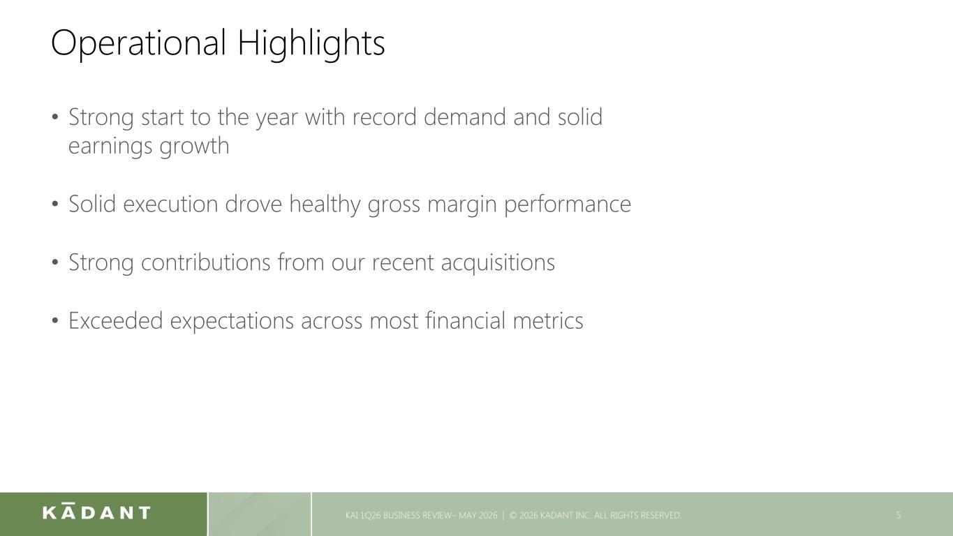
Operational Highlights 5 KAI 1Q26 BUSINESS REVIEW– MAY 2026 | © 2026 KADANT INC. ALL RIGHTS RESERVED. • Strong start to the year with record demand and solid earnings growth • Solid execution drove healthy gross margin performance • Strong contributions from our recent acquisitions • Exceeded expectations across most financial metrics 5

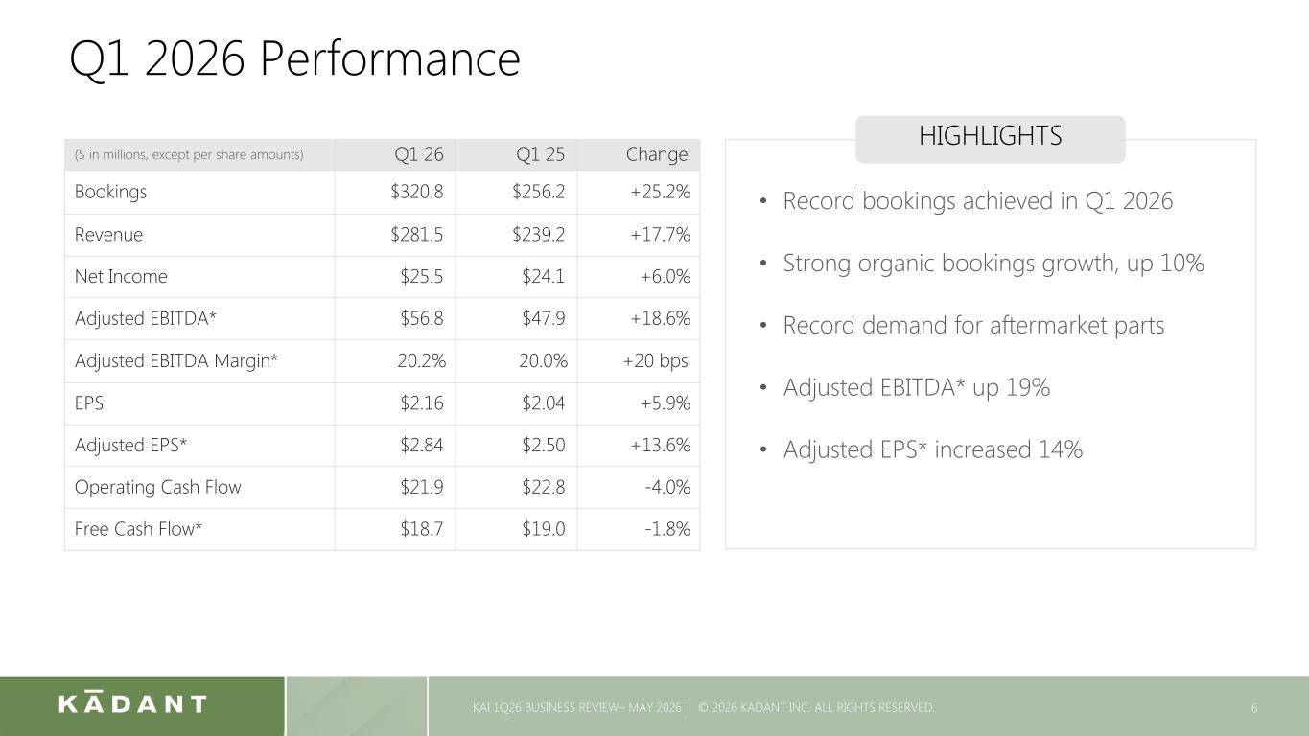
Q1 2026 Performance 6 ($ in millions, except per share amounts) Q1 26 Q1 25 Change Bookings $320.8 $256.2 +25.2% Revenue $281.5 $239.2 +17.7% Net Income $25.5 $24.1 +6.0% Adjusted EBITDA* $56.8 $47.9 +18.6% Adjusted EBITDA Margin* 20.2 % 20.0 % +20 bps EPS $2.16 $2.04 +5.9% Adjusted EPS* $2.84 $2.50 +13.6% Operating Cash Flow $21.9 $22.8 -4.0% Free Cash Flow* $18.7 $19.0 -1.8% HIGHLIGHTS • Record bookings achieved in Q1 2026 • Strong organic bookings growth, up 10% • Record demand for aftermarket parts • Adjusted EBITDA* up 19% • Adjusted EPS* increased 14% KAI 1Q26 BUSINESS REVIEW– MAY 2026 | © 2026 KADANT INC. ALL RIGHTS RESERVED.

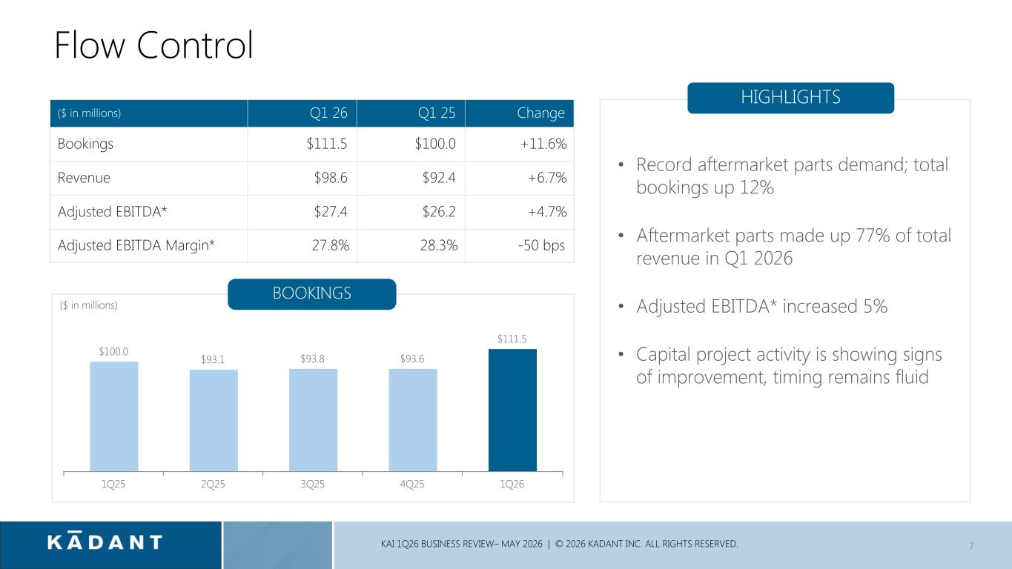
$100.0 $93.1 $93.8 $93.6 $111.5 1Q25 2Q25 3Q25 4Q25 1Q26 7 ($ in millions) Q1 26 Q1 25 Change Bookings $111.5 $100.0 +11.6 % Revenue $98.6 $92.4 +6.7 % Adjusted EBITDA* $27.4 $26.2 +4.7 % Adjusted EBITDA Margin* 27.8 % 28.3 % -50 bps HIGHLIGHTS • Record aftermarket parts demand; total bookings up 12% • Aftermarket parts made up 77% of total revenue in Q1 2026 • Adjusted EBITDA* increased 5% • Capital project activity is showing signs of improvement, timing remains fluid ($ in millions) BOOKINGS Flow Control KAI 1Q26 BUSINESS REVIEW– MAY 2026 | © 2026 KADANT INC. ALL RIGHTS RESERVED.

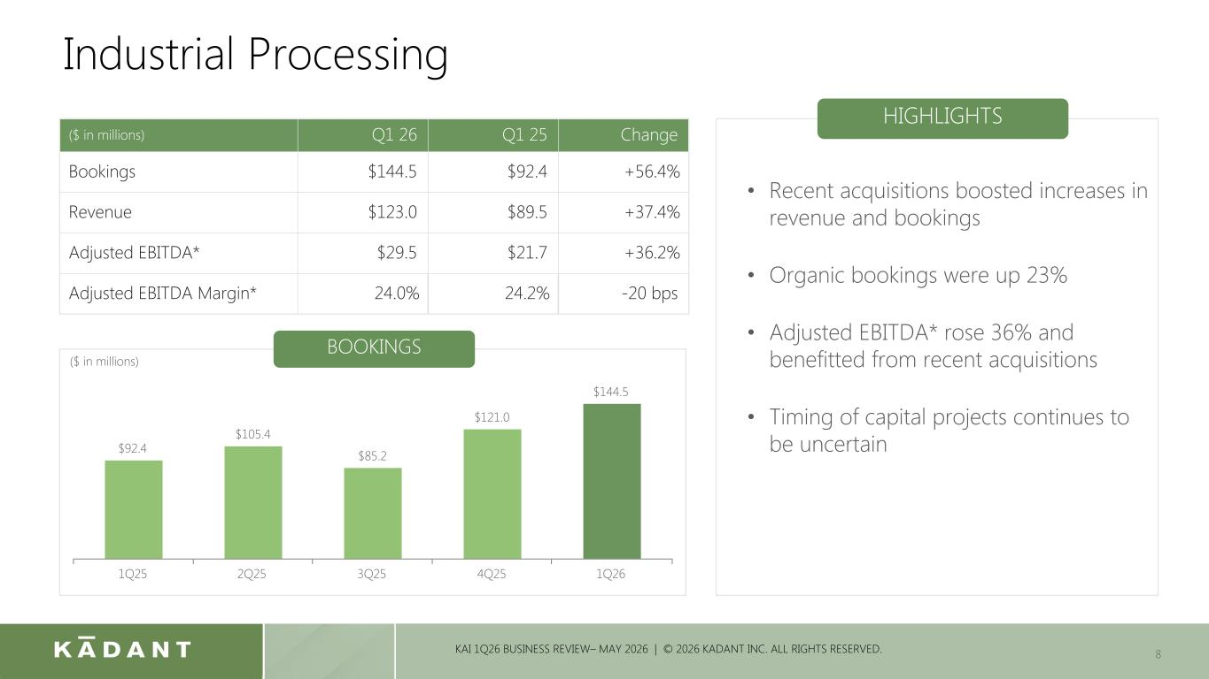
8 ($ in millions) Q1 26 Q1 25 Change Bookings $144.5 $92.4 +56.4% Revenue $123.0 $89.5 +37.4 % Adjusted EBITDA* $29.5 $21.7 +36.2 % Adjusted EBITDA Margin* 24.0 % 24.2 % -20 bps HIGHLIGHTS • Recent acquisitions boosted increases in revenue and bookings • Organic bookings were up 23% • Adjusted EBITDA* rose 36% and benefitted from recent acquisitions • Timing of capital projects continues to be uncertain Industrial Processing $92.4 $105.4 $85.2 $121.0 $144.5 1Q25 2Q25 3Q25 4Q25 1Q26 BOOKINGS ($ in millions) KAI 1Q26 BUSINESS REVIEW– MAY 2026 | © 2026 KADANT INC. ALL RIGHTS RESERVED.

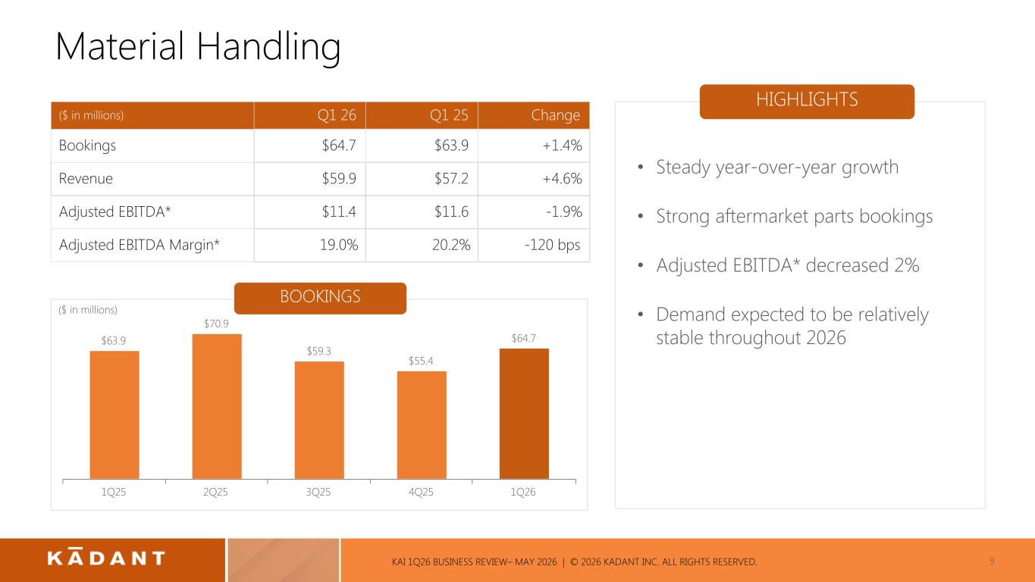
9 ($ in millions) Q1 26 Q1 25 Change Bookings $64.7 $63.9 +1.4% Revenue $59.9 $57.2 +4.6% Adjusted EBITDA* $11.4 $11.6 -1.9% Adjusted EBITDA Margin* 19.0 % 20.2 % -120 bps HIGHLIGHTS • Steady year-over-year growth • Strong aftermarket parts bookings • Adjusted EBITDA* decreased 2% • Demand expected to be relatively stable throughout 2026 Material Handling $63.9 $70.9 $59.3 $55.4 $64.7 1Q25 2Q25 3Q25 4Q25 1Q26 BOOKINGS ($ in millions) KAI 1Q26 BUSINESS REVIEW– MAY 2026 | © 2026 KADANT INC. ALL RIGHTS RESERVED.

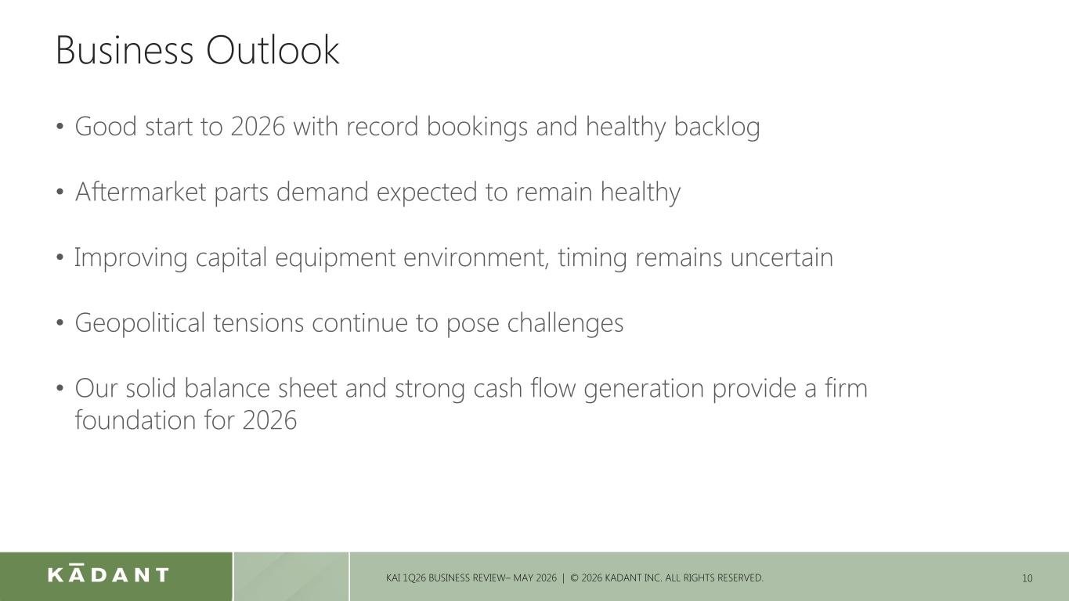
Business Outlook • Good start to 2026 with record bookings and healthy backlog • Aftermarket parts demand expected to remain healthy • Improving capital equipment environment, timing remains uncertain • Geopolitical tensions continue to pose challenges • Our solid balance sheet and strong cash flow generation provide a firm foundation for 2026 10KAI 1Q26 BUSINESS REVIEW– MAY 2026 | © 2026 KADANT INC. ALL RIGHTS RESERVED.

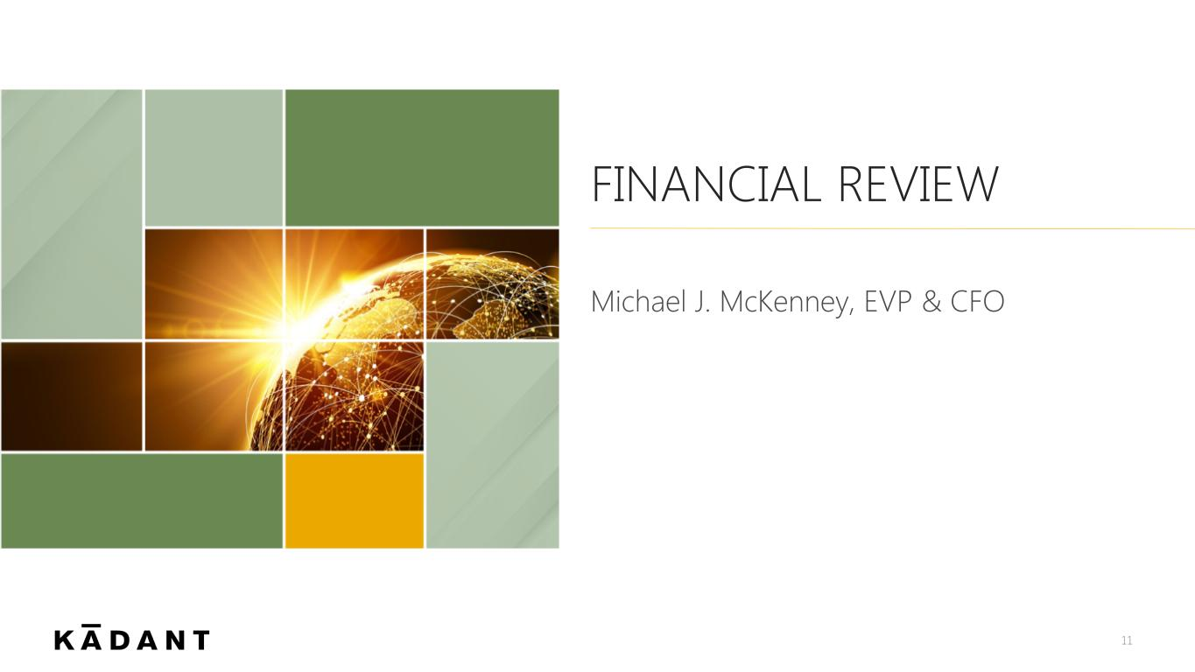
FINANCIAL REVIEW Michael J. McKenney, EVP & CFO 11

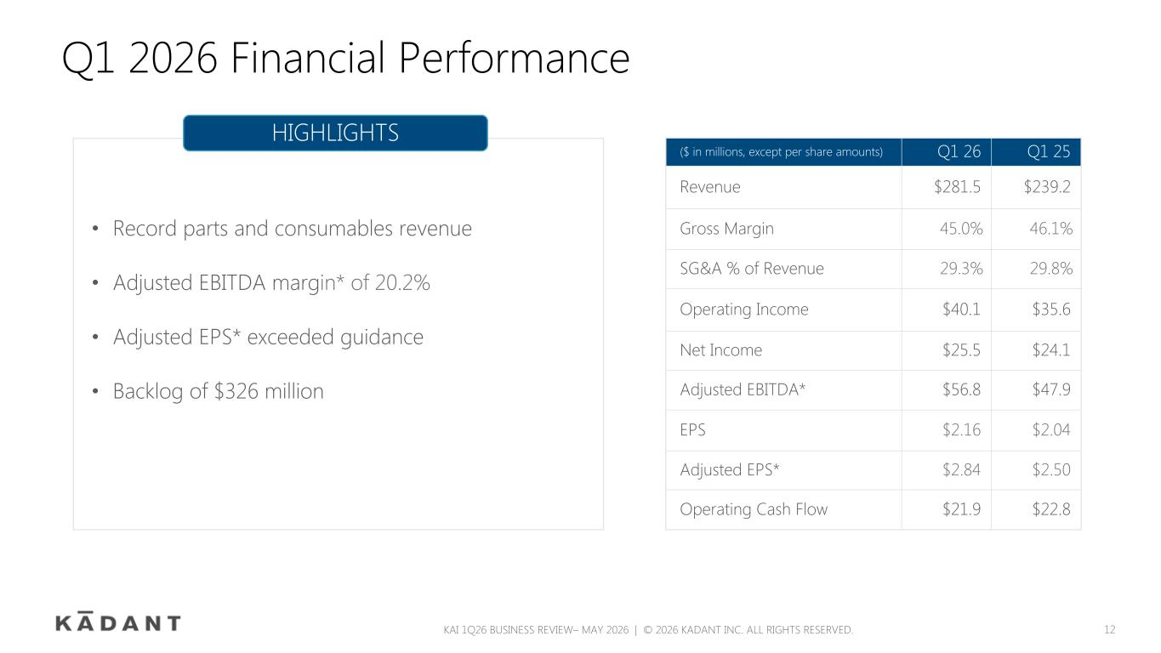
Q1 2026 Financial Performance ($ in millions, except per share amounts) Q1 26 Q1 25 Revenue $281.5 $239.2 Gross Margin 45.0% 46.1% SG&A % of Revenue 29.3% 29.8% Operating Income $40.1 $35.6 Net Income $25.5 $24.1 Adjusted EBITDA* $56.8 $47.9 EPS $2.16 $2.04 Adjusted EPS* $2.84 $2.50 Operating Cash Flow $21.9 $22.8 HIGHLIGHTS • Record parts and consumables revenue • Adjusted EBITDA margin* of 20.2% • Adjusted EPS* exceeded guidance • Backlog of $326 million KAI 1Q26 BUSINESS REVIEW– MAY 2026 | © 2026 KADANT INC. ALL RIGHTS RESERVED. 12

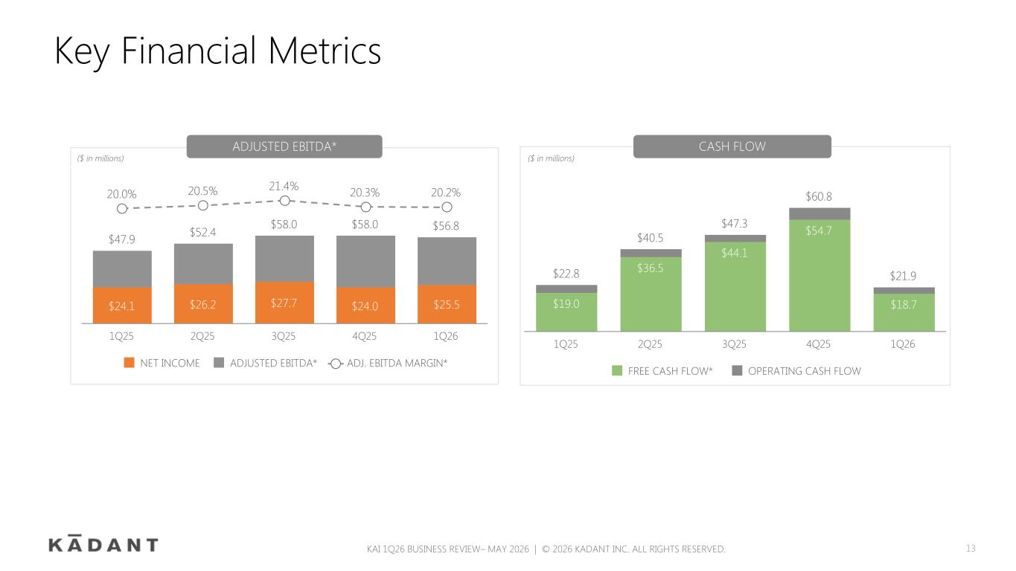
Key Financial Metrics KAI 1Q26 BUSINESS REVIEW– MAY 2026 | © 2026 KADANT INC. ALL RIGHTS RESERVED. 13 $22.8 $40.5 $47.3 $60.8 $21.9 $19.0 $36.5 $44.1 $54.7 $18.7 FREE CASH FLOW* OPERATING CASH FLOW 1Q25 2Q25 3Q25 4Q25 1Q26 $47.9 $52.4 $58.0 $58.0 $56.8 $24.1 $26.2 $27.7 $24.0 $25.5 20.0% 20.5% 21.4% 20.3% 20.2% NET INCOME ADJUSTED EBITDA* ADJ. EBITDA MARGIN* 1Q25 2Q25 3Q25 4Q25 1Q26 ADJUSTED EBITDA* CASH FLOW ($ in millions)($ in millions)

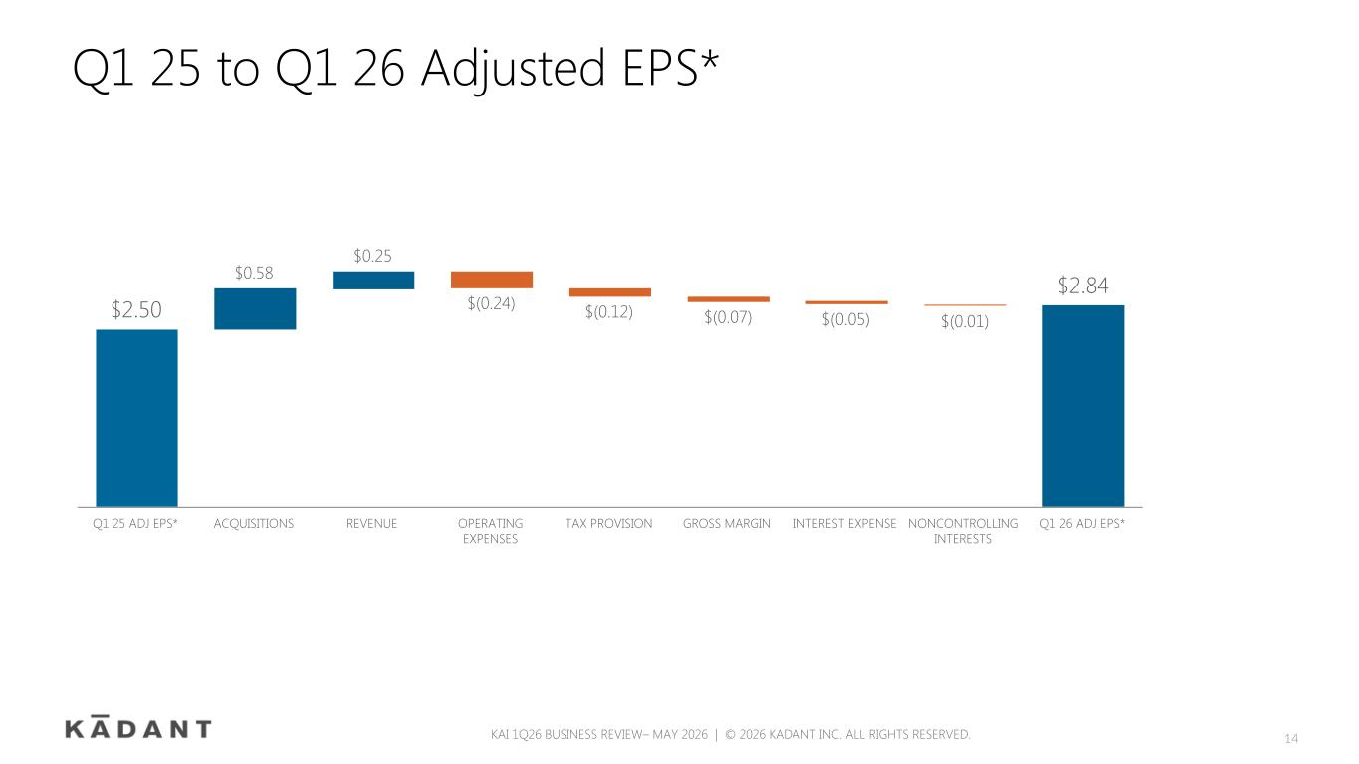
2Q21 ADJ EPS* 2Q22 ADJ EPS* KAI 1Q26 BUSINESS REVIEW– MAY 2026 | © 2026 KADANT INC. ALL RIGHTS RESERVED. Q1 25 to Q1 26 Adjusted EPS* $2.50 $0.58 $0.25 $(0.24) $(0.12) $(0.07) $(0.05) $(0.01) $2.84 Q1 25 ADJ EPS* ACQUISITIONS REVENUE OPERATING EXPENSES TAX PROVISION GROSS MARGIN INTEREST EXPENSE NONCONTROLLING INTERESTS Q1 26 ADJ EPS* 14

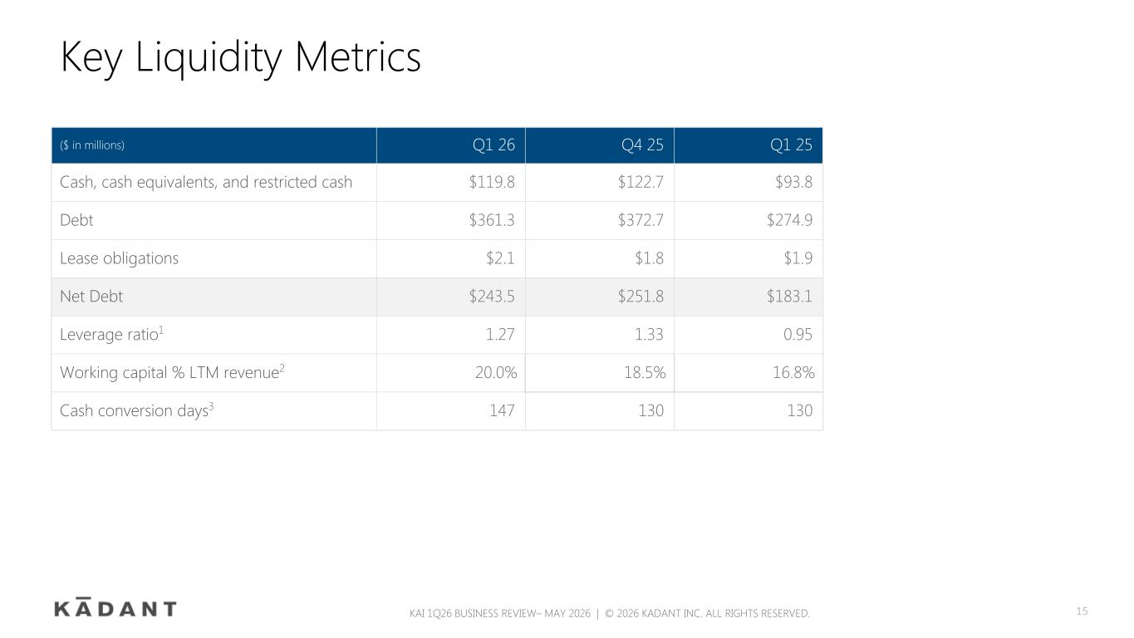
Key Liquidity Metrics KAI 1Q26 BUSINESS REVIEW– MAY 2026 | © 2026 KADANT INC. ALL RIGHTS RESERVED. ($ in millions) Q1 26 Q4 25 Q1 25 Cash, cash equivalents, and restricted cash $119.8 $122.7 $93.8 Debt $361.3 $372.7 $274.9 Lease obligations $2.1 $1.8 $1.9 Net Debt $243.5 $251.8 $183.1 Leverage ratio1 1.27 1.33 0.95 Working capital % LTM revenue2 20.0 % 18.5 % 16.8 % Cash conversion days3 147 130 130 15

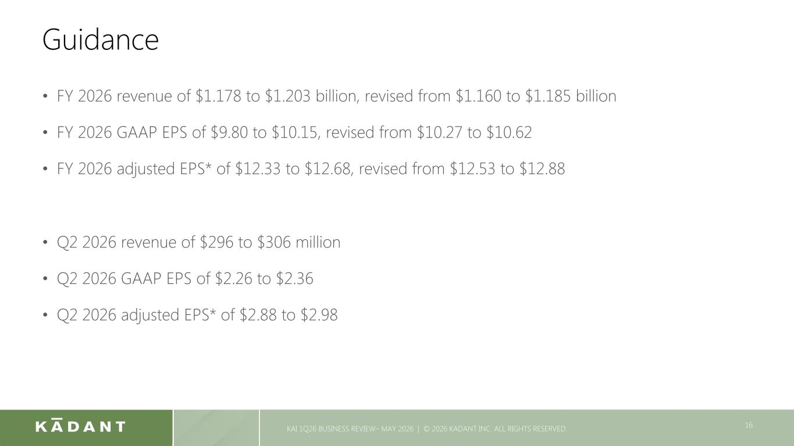
Guidance KAI 1Q26 BUSINESS REVIEW– MAY 2026 | © 2026 KADANT INC. ALL RIGHTS RESERVED. 16 • FY 2026 revenue of $1.178 to $1.203 billion, revised from $1.160 to $1.185 billion • FY 2026 GAAP EPS of $9.80 to $10.15, revised from $10.27 to $10.62 • FY 2026 adjusted EPS* of $12.33 to $12.68, revised from $12.53 to $12.88 • Q2 2026 revenue of $296 to $306 million • Q2 2026 GAAP EPS of $2.26 to $2.36 • Q2 2026 adjusted EPS* of $2.88 to $2.98


Questions & Answers To participate in the live Q&A session, please go to investor.kadant.com and click on the Q&A session link to receive a dial-in number and unique PIN. Please mute the audio on your computer. 17

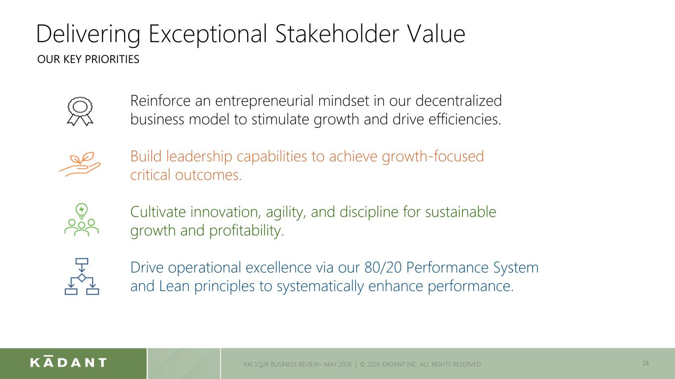
Delivering Exceptional Stakeholder Value 18KAI 1Q26 BUSINESS REVIEW– MAY 2026 | © 2026 KADANT INC. ALL RIGHTS RESERVED. Reinforce an entrepreneurial mindset in our decentralized business model to stimulate growth and drive efficiencies. Build leadership capabilities to achieve growth-focused critical outcomes. Cultivate innovation, agility, and discipline for sustainable growth and profitability. Drive operational excellence via our 80/20 Performance System and Lean principles to systematically enhance performance. OUR KEY PRIORITIES


Investor Relations Michael McKenney, 978-776-2000 IR@kadant.com Media Relations Wes Martz, 978-776-2000 media@kadant.com 19 CONTACTS

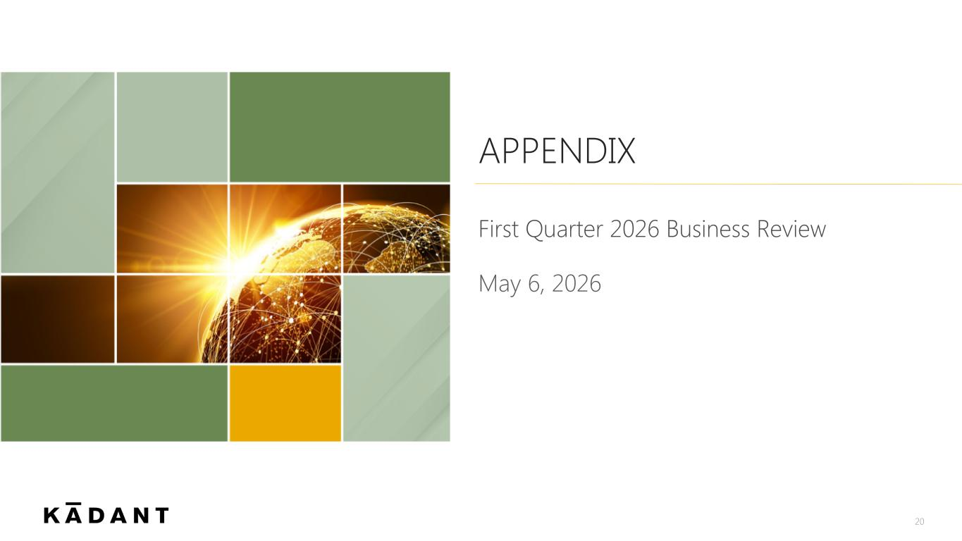
First Quarter 2026 Business Review 20 APPENDIX May 6, 2026

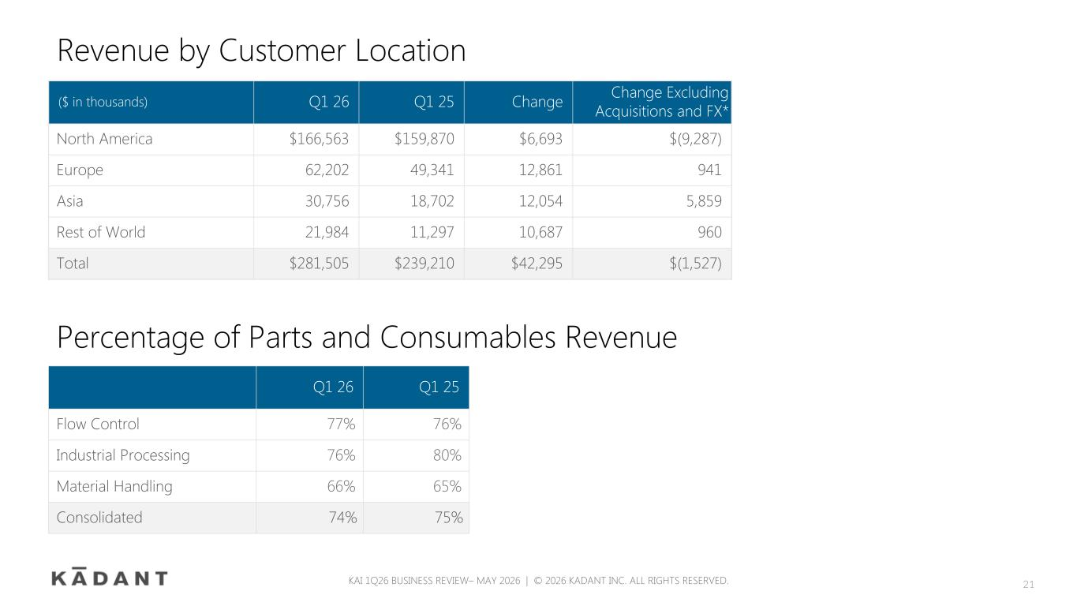
Revenue by Customer Location ($ in thousands) Q1 26 Q1 25 Change Change Excluding Acquisitions and FX* North America $166,563 $159,870 $6,693 $(9,287) Europe 62,202 49,341 12,861 941 Asia 30,756 18,702 12,054 5,859 Rest of World 21,984 11,297 10,687 960 Total $281,505 $239,210 $42,295 $(1,527) KAI 1Q26 BUSINESS REVIEW– MAY 2026 | © 2026 KADANT INC. ALL RIGHTS RESERVED. 21 Percentage of Parts and Consumables Revenue Q1 26 Q1 25 Flow Control 77% 76% Industrial Processing 76% 80% Material Handling 66% 65% Consolidated 74 % 75 %

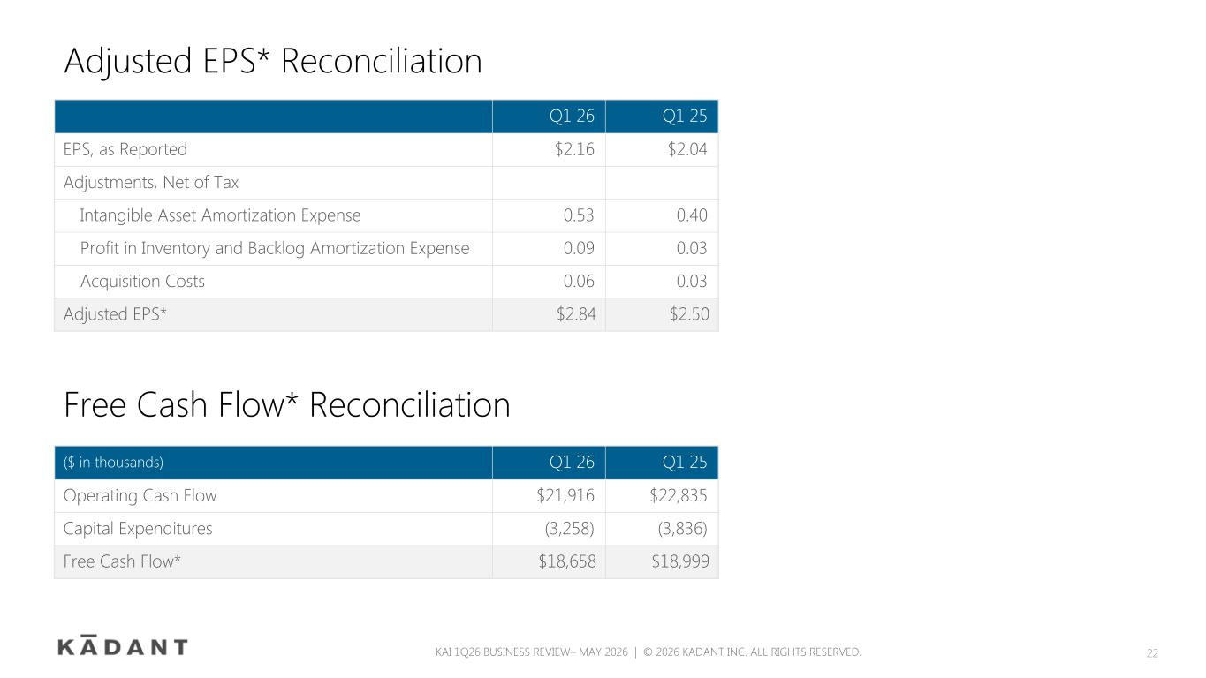
Adjusted EPS* Reconciliation Q1 26 Q1 25 EPS, as Reported $2.16 $2.04 Adjustments, Net of Tax Intangible Asset Amortization Expense 0.53 0.40 Profit in Inventory and Backlog Amortization Expense 0.09 0.03 Acquisition Costs 0.06 0.03 Adjusted EPS* $2.84 $2.50 KAI 1Q26 BUSINESS REVIEW– MAY 2026 | © 2026 KADANT INC. ALL RIGHTS RESERVED. 22 ($ in thousands) Q1 26 Q1 25 Operating Cash Flow $21,916 $22,835 Capital Expenditures (3,258) (3,836) Free Cash Flow* $18,658 $18,999 Free Cash Flow* Reconciliation

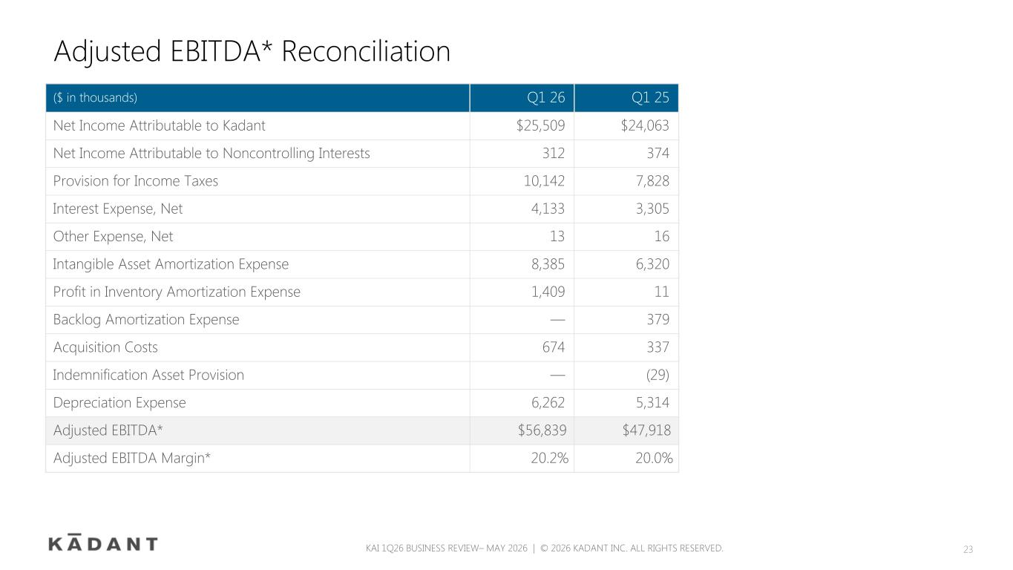
Adjusted EBITDA* Reconciliation ($ in thousands) Q1 26 Q1 25 Net Income Attributable to Kadant $25,509 $24,063 Net Income Attributable to Noncontrolling Interests 312 374 Provision for Income Taxes 10,142 7,828 Interest Expense, Net 4,133 3,305 Other Expense, Net 13 16 Intangible Asset Amortization Expense 8,385 6,320 Profit in Inventory Amortization Expense 1,409 11 Backlog Amortization Expense — 379 Acquisition Costs 674 337 Indemnification Asset Provision — (29) Depreciation Expense 6,262 5,314 Adjusted EBITDA* $56,839 $47,918 Adjusted EBITDA Margin* 20.2 % 20.0 % KAI 1Q26 BUSINESS REVIEW– MAY 2026 | © 2026 KADANT INC. ALL RIGHTS RESERVED. 23

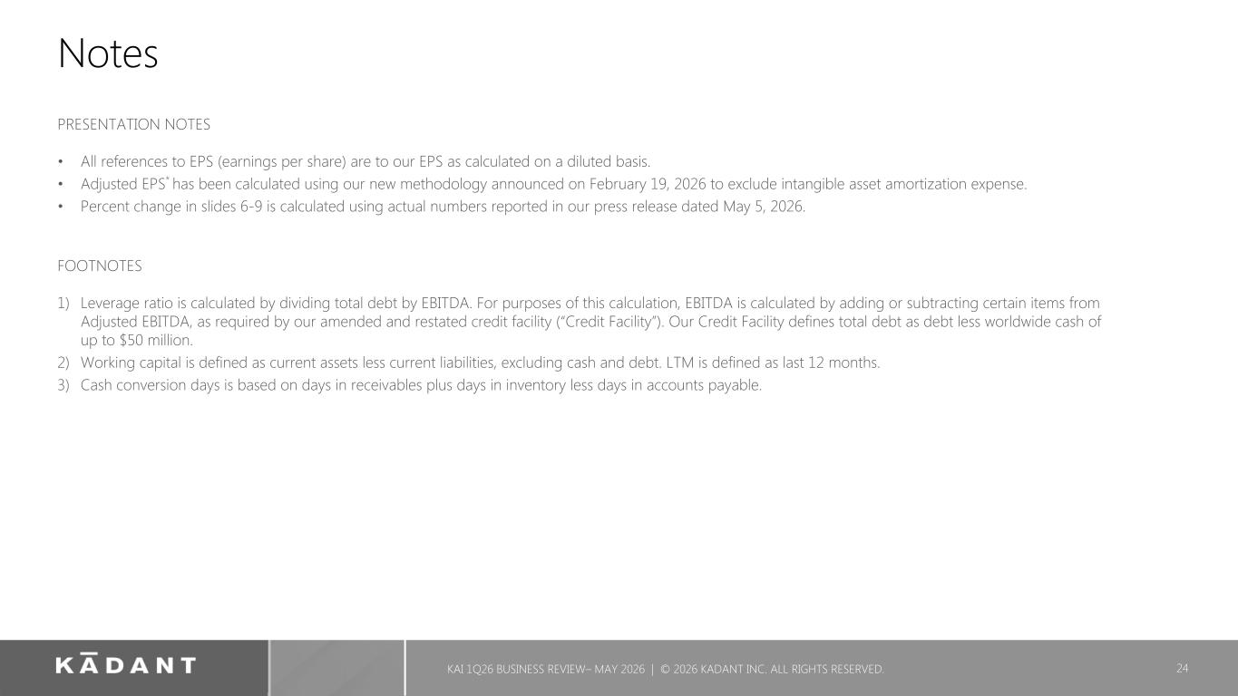
Notes PRESENTATION NOTES • All references to EPS (earnings per share) are to our EPS as calculated on a diluted basis. • Adjusted EPS* has been calculated using our new methodology announced on February 19, 2026 to exclude intangible asset amortization expense. • Percent change in slides 6-9 is calculated using actual numbers reported in our press release dated May 5, 2026. FOOTNOTES 1) Leverage ratio is calculated by dividing total debt by EBITDA. For purposes of this calculation, EBITDA is calculated by adding or subtracting certain items from Adjusted EBITDA, as required by our amended and restated credit facility (“Credit Facility”). Our Credit Facility defines total debt as debt less worldwide cash of up to $50 million. 2) Working capital is defined as current assets less current liabilities, excluding cash and debt. LTM is defined as last 12 months. 3) Cash conversion days is based on days in receivables plus days in inventory less days in accounts payable. KAI 1Q26 BUSINESS REVIEW– MAY 2026 | © 2026 KADANT INC. ALL RIGHTS RESERVED. 24

